**Weekly Schedule – April 20-24, 2020**

|  |  |  |  |  |  |
| --- | --- | --- | --- | --- | --- |
|  | **Monday** | **Tuesday** | **Wednesday** | **Thursday** | **Friday** |
| **8:00 -8:30** | Breakfast | Breakfast | Breakfast | Breakfast | Breakfast |
| **8:30-8:45** | Morning Meditation | Morning Meditation | Morning Meditation | Morning Meditation | Morning Meditation |
| **8:50-9:00** | **Reading** DEW Now | **Reading** DEW Now | **Reading** DEW Now | **Reading** DEW Now | **Submit** Mon-Thurs DEW Now |
| **9:00- 9:30** | **Reading** -iReady | **Reading** -iReady | **Reading** -iReady | **Reading** -iReady | **Reading** -iReady |
| **9:30- 10:00** | **Social Studies**  See Pg. 5 below | **Social Studies**  See Pg. 5 below | **Social Studies**  See Pg. 5 below | **Social Studies**  See Pg. 5 below | **Social Studies**  See Pg. 5 below |
| **10:00 – 11:00** | **Writing Prompt**  See Pg. 4 below | **Writing Prompt**  See Pg. 4 below | **Writing Prompt**  See Pg. 4 below | **Writing Prompt**  See Pg. 4 below | **Writing Prompt**  See Pg. 4 below |
| **11:00-11:30** | **Chores**- make your bed | **Chores**- do the dishes | **Chores**- read to your dog | **Chores**- sweep or vacuum floor | **Chores**- walk the dog |
| **11:30- 12:00** | **MUSIC**  Learn a new song | **ART**  Draw an abstract Self-portrait | **LIBRARY**  Write your own story and read to someone | **P.E.**  Make up a Tik Tok dance with a friend | **COMPUTER**  ABCYa  PBSKids  iReady |
| **12:00 – 12:30** | **Lunch** | **Lunch** | **Lunch** | **Lunch** | **Lunch** |
| **12:30- 1:00** | **Quiet Time** | **Quiet Time** | **Quiet Time** | **Quiet Time** | **Quiet Time** |
| **1:00-1:10** | **Math** DEW Now | **Math** DEW Now | **Math** DEW Now | **Math** DEW Now | **Submit** Mon-Thurs DEW Now |
| **1:10-1:40** | **Math** – iReady | **Math** – iReady | **Math** – iReady | **Math** – iReady | **Math** – iReady |
| **1:40- 2:00** | **Science - https://cleversso.discoveryeducation.com/learn/player/eb4a0a12-fa1f-4eac-9bb2-3a16cf05f790** | **Science -https://cleversso.discoveryeducation.com/learn/player/0e983fb2-f1a2-4717-bb9b-f44dfbe6d627** | **Science https://cleversso.discoveryeducation.com/learn/player/48ce4fa7-772a-47cd-b889-1665ee10938f** | **Science https://cleversso.discoveryeducation.com/learn/player/1c17440a-eacb-4508-9865-14fbcf20cd38** | **Science https://cleversso.discoveryeducation.com/learn/player/c563320d-1f6a-4863-8160-5f07da0f484** |
| **2:00-2:30** | **Free Play** – See pg. 6 “Coach Faulkner’s Activity Link” | **Free Play** – Run in place for 5 minutes | **Free Play** – See pg. 6 “Coach Faulkner’s Activity Link” | **Free Play** – 15 jumping jacks, or march around the house | **Free Play** – See pg. 6 “Coach Faulkner’s Activity Link” |

READING DEW NOW

MONDAY, APRIL 20, 2020

**A scorekeeper is an important person in sports. This is someone who keeps the official score. This job requires a lot. The scorekeeper has to watch the game very closely. Things can happen very quickly. This person also tracks other statistics. Each player is watched closely. All of the official numbers are tallied. They are shared at the end of the game**

**Which word best summarizes the topic of this text?**

1. **player**
2. **scorekeeper**
3. **game**

READING DEW NOW

TUESDAY, APRIL 21, 2020

Which title best describes the main idea of this text?

A. Number’s Game

B. Watching Closely

C. Adding It Up

D. Scorekeeper’s Job

Submit Dew Now Every FRIDAY by taking a picture and emailing to your Reading teacher! ☺

READING DEW NOW

WEDNESDAY, APRIL 22, 2020

What is the definition of tracks as it is used in this text?

A. path

B. rail

C. follows

D. songs

READING DEW NOW

THURSDAY, APRIL 23, 2020

What type of text would have language similar to the text?

A. an autobiography

B. a history book

C. a sports magazine

D. a newspaper

Submit DEW Now every FRIDAY by taking a picture of your work and emailing to your Math teacher! Use the RDW strategy! ☺

MATH DEW NOW

TUESDAY, APRIL RIL 21, 2020

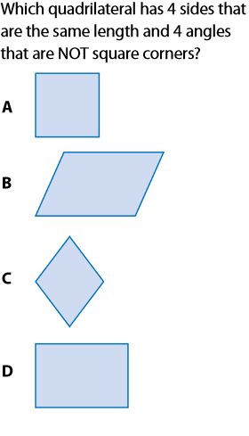

MATH DEW NOW

MONDAY, APRIL 20, 2020

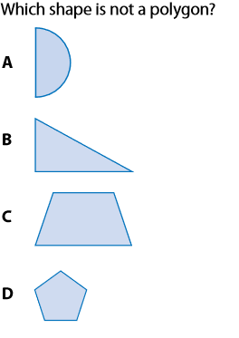

MATH DEW NOW

THURSDAY, APRIL 23, 2020

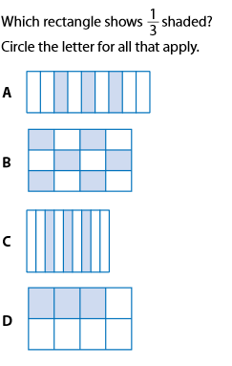

MATH DEW NOW

WEDNESDAY, APRIL 22, 2020

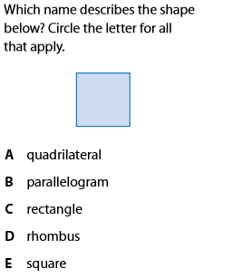

 What Are Those Stats?

Many people love the game of baseball. Some people enjoy playing the sport. Others enjoy watching the game. Many fans love to do both!

The rules of the game are simple. The score tells people who is winning. Yet that is not the only number used in the game. Baseball statistics use a lot of numbers and math. They give us data about the game.

Statistics, or stats, do not always matter to fans. Some people only want to know how a team is doing. They follow the final score of games. They also know about the standings. This is the ranking of a team compared to other teams. Knowing your team is in first place is enough for many fans.

Other fans want more specific information. Fans may want to compare players. Using stats is a way to rank a player. Which common stats do people follow? One is the number of hits a player has. How often a player makes a hit tells us about how well he is playing. So does his batting average. This number shows how often a player hits a ball during a season. Have you heard of an RBI? That stands for a run batted in. This is another important stat. It tells us how much a player helps his team score.

Sometimes stats are important to fans for a short time. This happens when a player is getting close to breaking a record. For example, a strong hitter may hit many home runs over his career. The player then might get close to the record for most home runs. People will start to pay attention. They will watch games to see if that player will change his statistics. It becomes a countdown. People focus on the statistic. Breaking a record in any sport is a very big deal! Without statistics, there wouldn’t be records to break!

Every time a player is up to bat, someone is watching. People are keeping score. They are also recording the events of the game. These become the record of a team’s season. These records are kept forever. Statistics tell the story of a game. They tell the story of a player’s performance. They are what baseball is all about.

**Reread “What Are Those Stats?” Then, read the prompt and write a respond.**

**Think about whether you would like to know these certain statistics as you watch a baseball game. Do you think these numbers make the game more exciting? Why or why not?**

**Social Studies**



[This Photo](http://misslwholebrainteaching.blogspot.com/2012/09/resources-to-start-off-your-week-35.html) by Unknown Author is licensed under [CC BY-SA-NC](https://creativecommons.org/licenses/by-nc-sa/3.0/)

**Monday**

What is one thing does not protect you during the spread of the Coronavirus?

a) Keeping your distance from others

b) Touching everything around you

c) washing my hands regularly

**Tuesday**

Which is not a good way to protect people around you?

a) cover your mouth when you sneeze

b) sneeze into your hand

c) turn your head when you sneeze

**Wednesday**

Which of the following places are consider essential?

a) park

b) mall

c) grocery store

**Thursday**

Who declared the ordinance for us to stay home for safety?

a) the president

b) the mayor

c) the school

**Coach Faulkner’s Fun Activities Link:**

A collection of short videos, Virtual P.E. and Family Fun Games:

<https://docs.google.com/presentation/d/e/2PACX-1vRI3NOGU90qOnnGhPqCieqVCmUeUM8RORcXOmPloEgB3DVXj0UqXq5t88cy9naa-pd96hIqgPs8NdCr/pub?start=false&loop=false&delayms=3000&fbclid=IwAR1TWwfvU3LBCKqckWPvRG_B82sOrgeiyMomwB5HDYVYasV8KMQDlgkn64M&slide=id.g830f8c2d40_1_5>

Announcements and Resources

* **Text MEALS or COMIDAS to 901-701-6777** to find nearby free meal distribution sites for families with children under age 18.
* **Envie COMDAS a 901-70106777** para mas informacion sobre servicios de comida disponible para familias con ninos.
* **GREAT NEWS!!! SCS now provides access to Discovery Education!** Students will be able to access Discovery Education lessons, virtual field trips, etc., via their Clever Log-in. Stay tuned for more information.
* **Check your ClassDojo Weekly!**
* **Weekly Learning Guides**: <http://www.scsk12.org/instructionalresources/grade?PID=1639>
* **Family Resources:** <http://www.scsk12.org/coronavirusfacts/studentmeals>
* Please email your teacher 24 hours prior to scheduling office hours appointments. The teacher will then send confirmation and further details about the virtual meeting.

Office Hours

Mrs. Greenburg MON/WED 9:00 am- 11:00 am; 1:00 pm – 3:00 pm [greenburgjf@scsk12.org](mailto:greenburgjf@scsk12.org)

Mrs. Mitchell MON/ WED 9:00 am-11:00 am; 1:00 pm- 3:00 pm [mitchelll2@scsk12.org](mailto:mitchelll2@scsk12.org)

Mrs. Harris MON/ WED 9:00 am- 11:00 am; 1:00 pm – 3:00 pm [harriss8@scsk12.org](mailto:harriss8@scsk12.org)

Ms. McClain MON/ WED 9:00 am- 11:00 am; 1:00 pm-3:00 pm [mcclainv@scsk12.org](mailto:mcclainv@scsk12.org)

Mrs. Rhodes MON/ WED 9:00 am – 11:00 am; 1:00 pm -3:00 pm [wadeal@scsk12.org](mailto:wadeal@scsk12.org)